Web Application using .NET

## Based on Google Drive API and GMAIL API

Contents

Based on Google Drive API and GMAIL API 1

Initial Steps 1

ASP.NET Web Application using VB 1

Enabling the Gmail API and Google Drive API 2

Packages 3

Application Output 3

# Initial Steps

* Select New Project – Visual Studio 2017
* Visual Basic – Web – Asp.NET Web Application with Empty project selected.
* Web form was added, designed and code.
* HTML page was added.
* Required packages added using NuGeT Console.

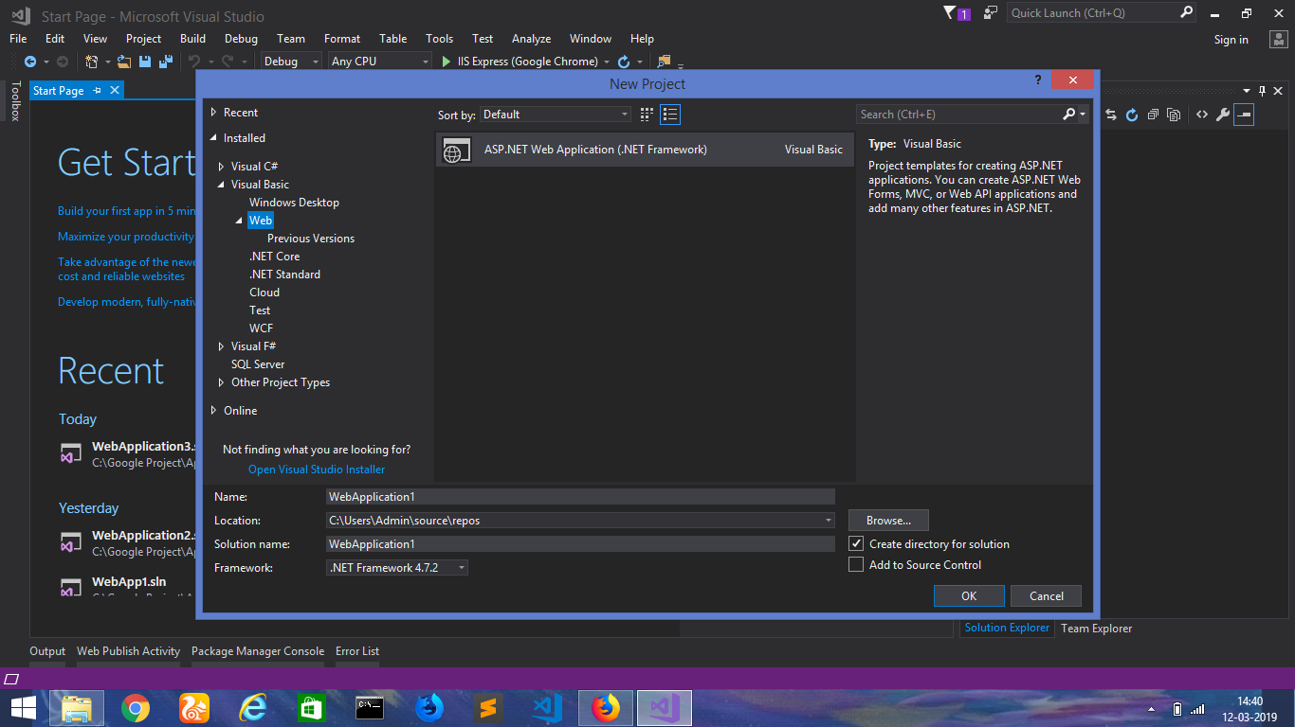

# ASP.NET Web Application using VB

Web Form – It was designed using the toolbar for placing image on top, with buttons for **sign in to Google**, **upload and download files from Google Drive**. It also has browse and select button in between.

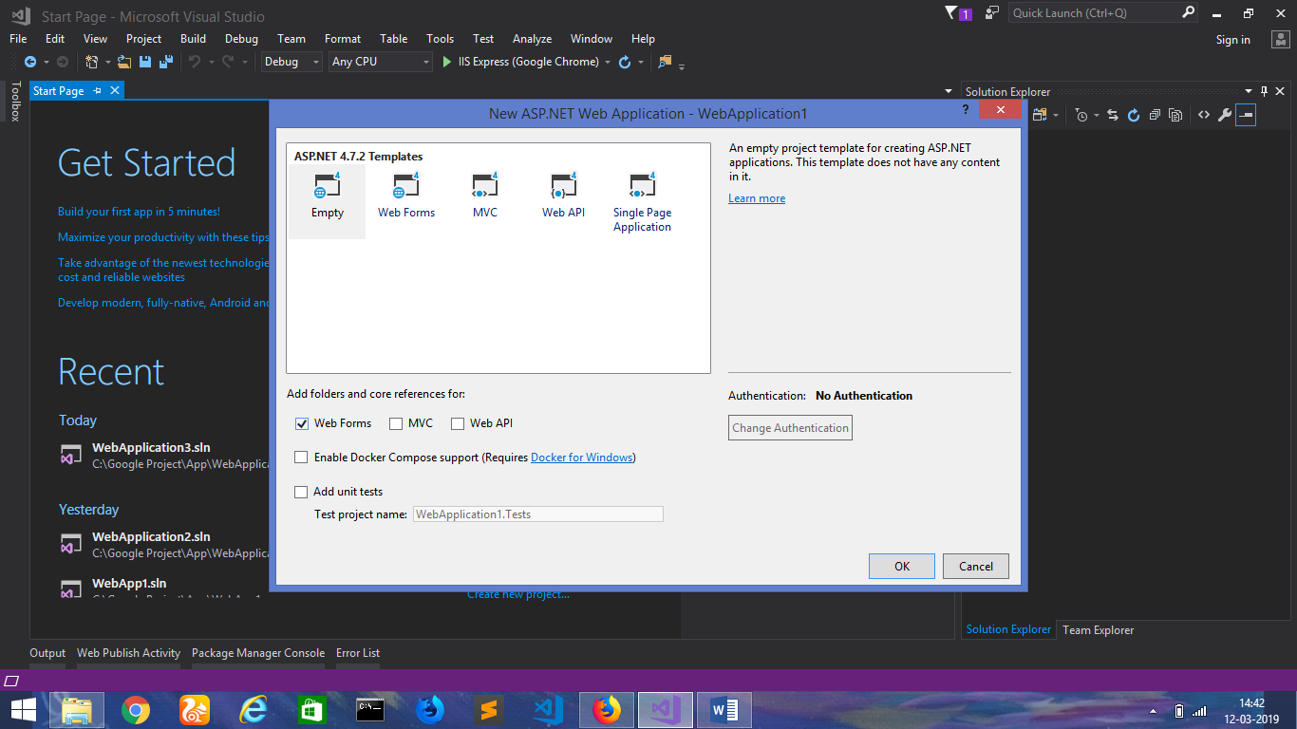

# Enabling the Gmail API and Google Drive API

For this web application project, both the API’s required documents and reference used to enable API, use credentials and implement the code. The sample picture after enabling API from a page.

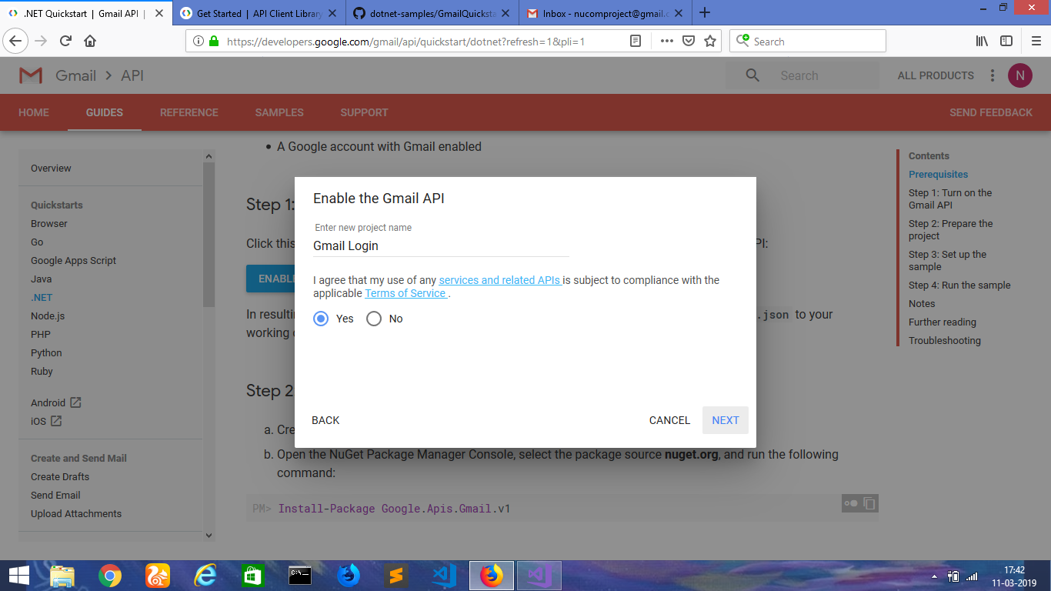

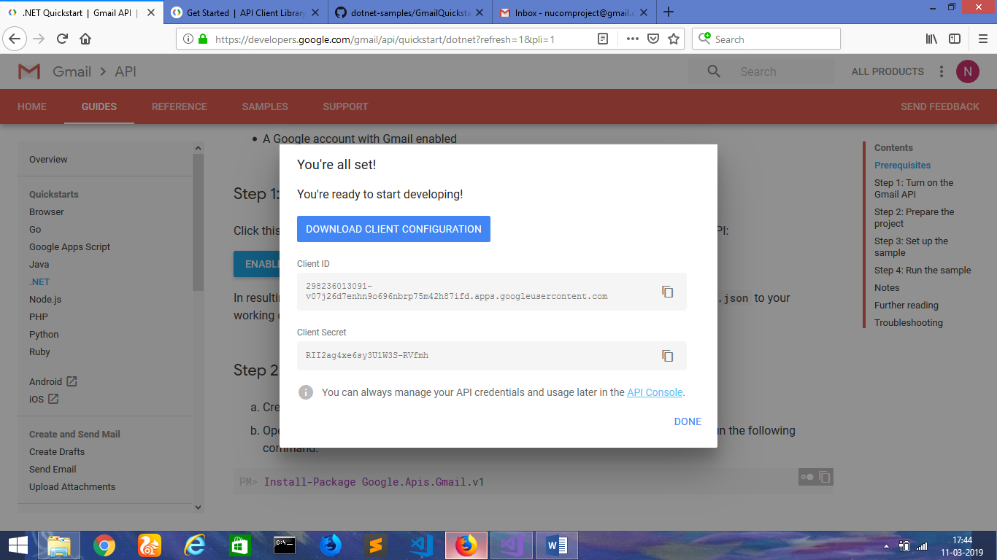

Next, -- console.developers.google.com – to enable api and set the required credentials to use the Client ID, client secret and API key.

Doc reference:

To enable an API for your project:

1. Go to the [API Console](https://console.developers.google.com).
2. From the projects list, select a project or create a new one.
3. If the APIs & services page isn't already open, open the console left side menu and select **APIs & services**, and then select **Library**.
4. Click the API you want to enable. If you need help finding the API, use the search field.
5. Click **ENABLE**.

# Packages

Using the following command, installed a package related to Google Drive:

**PM> Install-Package Google.Apis.Drive.v2**

A list of packages were installed using NuGeT Package Console. It is available in the Packages Config file.

<?xml version="1.0" encoding="utf-8"?>

<packages>

<package id="Google.Apis" version="1.38.0" targetFramework="net472" />

<package id="Google.Apis.Auth" version="1.38.0" targetFramework="net472" />

<package id="Google.Apis.Core" version="1.38.0" targetFramework="net472" />

<package id="Google.Apis.Drive.v2" version="1.38.0.1512" targetFramework="net472" />

<package id="Google.Apis.Gmail.v1" version="1.38.0.1495" targetFramework="net472" />

<package id="Microsoft.CodeDom.Providers.DotNetCompilerPlatform" version="2.0.0" targetFramework="net472" />

<package id="Newtonsoft.Json" version="10.0.2" targetFramework="net472" />

</packages>

# Application Output

The frontendform.aspx runs on localhost:57538 and this is the front UI.

Sign-in GMAIL - Button to access GMAIL, opens up an HTML file with a button to use Gmail Api for login purpose.

Choose File – Browse and select the file. A window opens for the user to select.

Upload File – Button to upload file to Google drive. The Google drive API code was added and enabled with credentials, but the output had some issues.

DownloadFile – Button to download files. This button has no code behind.

Form > the front end of the application.

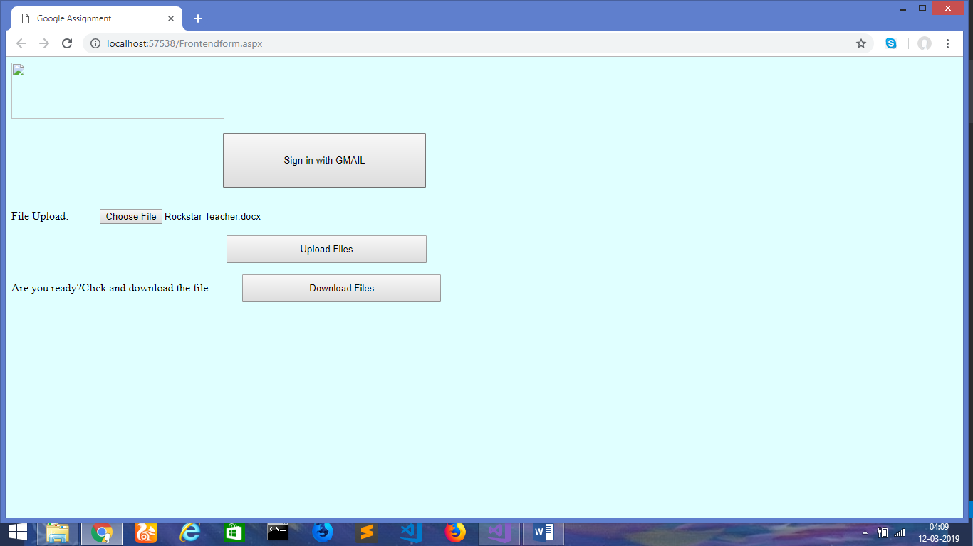

Click > Sign in with GMAIL, sends to the following HTML page. On clicking Authorize

Button, the login option for the user as depicted below.

